Ourschooltrip to York
The first day of our trip to York was very long. We sat on the bus and watched through windows. Our path led through Germany, the Netherlands and Belgium. At 12:00 the next day we were in Belgium. Here we had to get on a boat. Before we boarded the boat we were in the Belgičan town. The journey on the ship was quite long but comfortable. Upon our arrival to England, we waited for about 5 hour journey to York. In the afternoon we walked along York and in the evening our families came to accommodate us.
The next two days we went to school that we started at 9 am and ended about 1 o'clock in the afternoon. Every afternoon we were to look at the sights and we were also in the underwaterworld.
At the beginning of the day we said goodbye to the families and went to London where we spent half a day. After visutiny the London Eye, we went to the bus. Three days passed very quickly and w Esere again on the way home.
This timethe journey was even longer. Although we drove only about 2 hours on the boat, but the highways are often expected. We arrived to the Czech Republic and we were eagerly looking out something familiar about what he told us about where we are. After the last stop, we know 100% in what time we'll be home. Until we arrived to Hustopeče just saw our parents who were waiting impatiently for us.
Fo rmyself I evaluate the trip to York very well. D.Hájek
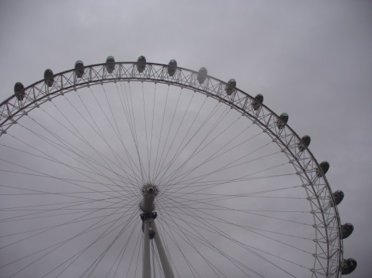
Tth
This is the London Eye
Due to the fact that we were there in the evening so we could see London at night.
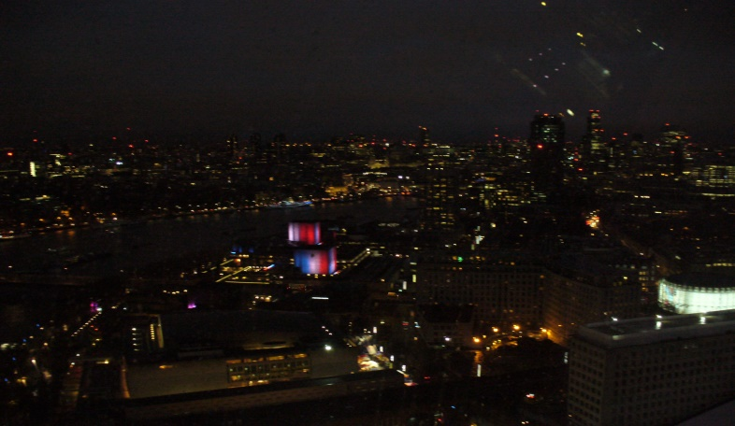

And this is London at night
That's how we saw it from a stall on. That's how we saw it from a stall on London Eye

